**Chapter 1**

**Market Segmentation**

**1.1 Strategic and Tactical Marketing**

* Marketing serves as a bridge between consumer needs and supplier offers.
* Strategic marketing: Purpose is to match consumer needs with supplier offers.
* Strategic planning: Logical sequence leading to setting long-term marketing objectives.
* Components: Strategic plan outlines long-term direction; tactical plan translates it into short-term instructions.
* Hiking analogy: Strategic decision (choosing the mountain) determines the long-term direction; tactical decisions (gear, timing) depend on it.
* Tactical marketing plan: Covers product development, pricing, distribution, and promotion for a one-year period.
* Dependency: Tactical plan relies entirely on the strategic foundation.
* Relationship analogy: Strategic marketing picks the right mountain; tactical marketing ensures quality gear.
* Success synergy: Robust strategic and tactical marketing lead to the best outcome.
* Tactical plan duration: Typically covers up to one year.
* Areas covered: Product development, pricing, distribution channels, and promotion.
* Outcome scenarios: Good strategic + good tactical = Best outcome; bad strategic + bad tactical = Failure (unfolds slowly); excellent tactical + bad strategic = Fast-track to failure; good strategic + bad tactical = Survival but not ideal.

**1.2 Definitions of Market Segmentation**

**Definition and Importance:**

* Market segmentation is a decision-making tool crucial for selecting a target market and designing a suitable marketing mix.
* It is a key building block of strategic marketing and is essential for marketing success.
* Successful firms base their business strategies on segmentation, emphasizing its pivotal role in marketing decisions.

**Historical Perspective:**

* Smith (1956) proposed segmentation as a marketing strategy, defining it as breaking down a heterogeneous market into smaller, homogeneous markets.
* Market segmentation conceptually sits between the extreme views that all objects are unique and inviolable, and the population is homogeneous.

**Segmentation Criteria:**

* Involves consumer characteristics critical to management, known as segmentation criteria.
* Criteria can be single characteristics like age, gender, or a set of characteristics like benefits sought, vacation activities, values, or expenditure patterns.

**Illustrative Example:**

* Ideal segmentation illustrated with a mobile phone market example, depicting three segments with distinct preferences for features and pricing.
* Highlights the importance of catering to specific market segments for organizational success.

**Strategic Approaches:**

* Concentrated Strategy: Focuses on one market segment, suitable for resource-poor organizations facing intense competition. Comes with higher risk.
* Differentiated Strategy: Targets multiple segments, customizing the marketing mix for each. Suitable for mature markets where consumers can differentiate between products.
* Undifferentiated Strategy: Targets the entire market with the same product and marketing mix. Viable for resource-rich organizations or during the introduction of new products.

**Key Takeaways:**

* Market segmentation ensures that diverse consumer needs are addressed, leading to a distinct market image.
* Choosing a concentrated or differentiated strategy depends on resource availability and market maturity.
* Undifferentiated strategies may be suitable for resource-rich organizations or in the early stages of product introduction.

In summary, market segmentation is not just a tool; it's a strategic imperative for organizations aiming to thrive in a dynamic marketplace. Understanding and effectively implementing segmentation strategies are critical for achieving long-term success and sustaining a competitive edge.

**1.3 The Benefits of Market Segmentation**

1. Strategic Reflection:
   * Forces organizations to assess their current position and future goals.
   * Prompts reflection on organizational strengths compared to competitors.
   * Encourages understanding consumer wants and needs.
2. Insights and Perspectives:
   * Offers opportunities for critical thinking, leading to new insights.
   * Facilitates a deeper understanding of consumer differences.
3. Tangible Benefits:
   * Enhances the match between organizational strengths and consumer needs.
   * Forms the basis for a long-term competitive advantage in selected segments.
   * Can lead to market dominance in specific niche segments.
4. Micro Marketing and Hyper-Segmentation:
   * Extreme segmentation, known as micro marketing or hyper-segmentation.
   * Customized offerings for very small consumer groups become feasible.
   * Finer segmentation, with each consumer as a separate segment, enabled by eCommerce and sophisticated databases.
5. Efficient Marketing Mix:
   * Develops a marketing mix tailored to the needs of one or more segments.
   * Yields a higher return on investment by avoiding efforts on consumers whose needs the organization cannot satisfy.
6. Survival for Small Organizations:
   * Essential for the survival of small organizations with limited resources.
   * Allows focusing on satisfying distinct needs of a small consumer group.
7. Effectiveness in Sales Management:
   * Effective in sales management by allowing targeted sales efforts at groups of consumers.
   * Shifts focus from individual consumers to strategically targeted consumer groups.
8. Contribution to Team Building:
   * At the organizational level, contributes to team building.
   * Tasks associated with market segmentation analysis require collaboration among different organizational units.
   * Successful team efforts can improve communication and information sharing across organizational units.

**1.4 The Costs of Market Segmentation**

**:**

1. **Substantial Investment:**
   * Implementation requires a significant investment of time and financial resources.
   * Involves a large number of people dedicated to conducting a thorough market segmentation analysis.
2. **Resource Requirements:**
   * Pursuing a segmentation strategy demands more human and financial resources.
   * Developing and implementing a customized marketing mix adds to resource demands.
3. **Ongoing Commitment:**
   * Continuous monitoring and evaluation of the segmentation strategy require ongoing commitment of resources.
   * Resource commitments are made with the expectation of a return on investment.
4. **Risk of Failed Strategy:**
   * In the worst case, poorly implemented market segmentation leads to wasted resources.
   * A failed strategy may result in substantial expenses without generating additional returns, potentially disenfranchising involved staff.
5. **Informed Decision-Making:**
   * Organizations need to make informed decisions on whether to embark on market segmentation analysis.
   * The decision to pursue a market segmentation strategy is a long-term commitment requiring careful consideration of potential risks and benefits.

**Chapter 2**

**Market Segmentation Analysis**

**2.1 The Layers of Market Segmentation Analysis**

Core Process:

* Involves grouping consumers into segments based on similar product preferences or characteristics.
* A statistical and exploratory process, decisions made by data analysts impact the final segmentation solution.

User Involvement:

* Requires involvement of both a competent data analyst and a user who understands the organization's mission.
* The term "user" refers to the individual or department utilizing the segmentation analysis results for marketing planning.

Quality Assurance Tasks:

* Technical tasks in the second layer include collecting good data, exploring data before segmentation, and profiling and describing segments.
* Profiling helps users understand and select target segments, informing the development of a customized marketing mix.

Implementation Layer:

* A third layer involves non-technical tasks for organizational implementation issues.
* Users must assess whether implementing a segmentation strategy aligns with market opportunities and commit to a long-term strategy.

User Decision-Making:

* Decisions about strategy, commitment, and target segment selection are made by users, independent of technical tasks.
* User input is crucial at the data collection stage to capture relevant consumer information.

Market Opportunities Assessment:

* Before technical tasks, the organization needs to assess whether market segmentation will unveil new opportunities.
* Users must decide to commit to a long-term strategy if opportunities are identified.

**2.2 Approaches to Market Segmentation Analysis**

No One-Size-Fits-All Approach:

* No single approach is universally best for market segmentation analysis.
* Various approaches can be systematized based on different criteria.

Two Systematics Presented:

* The first systematics, proposed by Dibb and Simkin (2008), categorizes approaches based on the organization's willingness or ability to make changes to its current targeting approach.
* The second systematics is based on the nature of the segmentation variables used in the analysis.

Dibb and Simkin's Systematics:

* Categorizes approaches based on organizational constraints and their ability to make changes to current targeting methods.
* Acknowledges that organizations may be limited in their choices due to constraints.

Nature of Segmentation Variables:

* The second systematics categorizes approaches based on the nature of segmentation variables used in the analysis.
* This categorization focuses on the characteristics or attributes that form the basis for segmenting the market.

**2.3 Data Structure and Data-Driven Market Segmentation**

**Approaches**

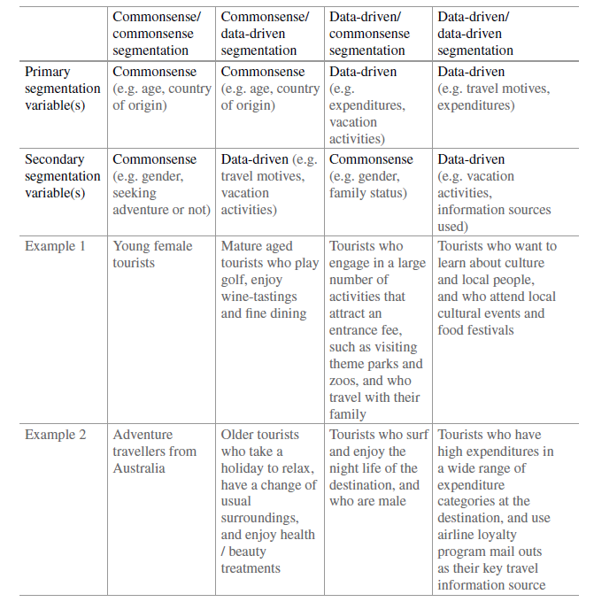

**2.4 Market Segmentation Analysis Step-by-Step**

1. **Define Objectives:**
   * Clearly outline the objectives of the segmentation analysis.
2. **Data Collection:**
   * Gather relevant and high-quality data about consumer preferences and characteristics.
3. **Preliminary Data Exploration:**
   * Explore collected data to gain initial insights into the nature of the segmentation study.
4. **Select Segmentation Variables:**
   * Choose the variables or characteristics for segmenting the market based on the nature of the study.
5. **Segmentation Process:**
   * Utilize statistical and exploratory methods to group consumers into segments.
6. **Quality Assurance:**
   * Ensure the grouping of consumers is of the highest quality by validating and refining the segmentation solution.
7. **Profile and Describe Segments:**
   * Develop detailed profiles for each segment, describing their unique characteristics.
8. **User Involvement:**
   * Involve users in assessing resulting segments and selecting one or more target segments.
9. **Strategic Decision-Making:**
   * Evaluate whether implementing a segmentation strategy aligns with market opportunities and commit to a long-term strategy.
10. **Develop Marketing Plan:**
    * Create a marketing plan tailored to the selected target segment(s).
11. **Continuous Monitoring:**
    * Continuously monitor market dynamics and evaluate the success of the segmentation strategy.
12. **Adjust Strategy as Needed:**
    * Modify the segmentation strategy based on ongoing evaluations and changes in market dynamics.
13. **User-Centric Approach:**
    * Emphasize user involvement at every stage for effective translation of segmentation results into strategic marketing decisions and actions.

**Chapter 3**

**Step 1: Deciding (not) to Segment**

**3.1 Implications of Committing to Market Segmentation**

1. Long-term Commitment: Market segmentation requires a sustained commitment, likened to a marriage, involving substantial changes and investments.
2. Cost Considerations: Cahill emphasizes that market segmentation is not free; there are costs associated with research, surveys, package and advertisement design.
3. Profitability Requirement: Segmentation strategy should only be pursued if the expected increase in sales justifies the expenses, making it more profitable than marketing without segmentation.
4. Organizational Changes: Implementation may necessitate new product development, modifications, pricing adjustments, and changes in distribution channels, impacting the internal structure of the organization.
5. Organizational Structure: Croft suggests organizing around market segments, not just products, to maximize the benefits of market segmentation.
6. Executive Decision: The decision to explore market segmentation must be made at the highest executive level and continuously communicated across all organizational levels.
7. Strategic Business Units: To maintain focus on changing market segment needs, strategic business units aligned with segments offer a suitable organizational structure.
8. Continuous Communication: The decision and commitment to market segmentation must be systematically communicated and reinforced at all levels and units within the organization.

**3.2 Implementation Barriers**

1. **Resource Constraints:** Limited budget and manpower can hinder the execution of market segmentation due to associated research, design, and communication costs.
2. **Resistance to Change:** Organizational inertia and resistance from employees can impede the necessary adjustments in product development, pricing, and communication strategies.
3. **Lack of Data:** Insufficient or inaccurate data about target markets can pose a significant barrier to effective segmentation implementation.
4. **Complexity and Time:** The complexity of restructuring and realigning organizational processes, along with the time required for these changes, can be a significant impediment.
5. **Inadequate Leadership Support:** Lack of strong executive support and buy-in can undermine the successful implementation of market segmentation by leading to inconsistent communication and commitment across the organization.

**Chapter 10**

**Step 8: Selecting the Target Segment(s)**

**10.1 The Targeting Decision**

1. **Strategic Decision:** Selecting target market segments is a critical, long-term strategic decision with a profound impact on the organization's future performance.
2. **Transition from Exploration to Commitment:** After global market segmentation, the focus shifts from exploration (flirting and dating) to commitment, akin to buying a ring and popping the question.
3. **Segment Selection Process:** Post global segmentation, segments are detailed in Steps 6 and 7. In Step 8, one or more segments are chosen based on previously established knock-out criteria and attractiveness criteria.
4. **Knock-out Criteria Application:** Knock-out criteria, determined in Step 2, are optimally applied in previous steps. Segments failing these criteria are eliminated based on size, homogeneity, distinctiveness, identifiability, reachability, and alignment with organizational capabilities.
5. **Attractiveness Evaluation:** Remaining segments are evaluated for attractiveness and organizational competitiveness. Key questions include which segments the organization would most like to target and commit to, as well as how likely each segment is to choose the organization over competitors.
6. **Basis for Decision:** Answers to these questions form the foundation for the final target segment decision, influencing the organization's marketing strategy and long-term commitment to specific market segments.

**10.2 Market Segment Evaluation**

Market segment evaluation is a crucial step in the strategic marketing process where organizations assess and prioritize potential target segments. This involves a meticulous examination of segments based on predetermined criteria, considering factors like size, homogeneity, distinctiveness, identifiability, and reachability. Following the application of knock-out criteria established earlier, the remaining segments are then evaluated for attractiveness and organizational competitiveness. Key questions guide this evaluation, such as which segments align with the organization's goals and capabilities, and how likely each segment is to choose the organization over competitors. The insights gained from this evaluation form the basis for selecting the target market segments, influencing long-term commitment and shaping the organization's marketing strategy.

**Chapter 11**

**Step 9: Customising the Marketing Mix**

**11.1 Implications for Marketing Mix Decisions**

1. Product: The organization may need to customize or develop products/services that align with the preferences and demands of the chosen market segments. This could involve variations in features, design, packaging, or even the introduction of entirely new offerings.
2. Price: Pricing strategies should be adapted to the perceived value of the product or service within the selected segments. Different segments may have varying price sensitivities, requiring adjustments to pricing structures to remain competitive and appealing.
3. Place (Distribution): Distribution channels and methods must be selected to ensure products reach the chosen market segments efficiently. This may involve partnerships, specific retail locations, or online platforms that resonate with the target audience.
4. Promotion: Marketing communications and promotional activities should be tailored to the characteristics and preferences of the target segments. This includes selecting appropriate channels, crafting messages that resonate with the audience, and utilizing promotional tactics that appeal to the specific segment's interests.
5. People (Customer Service): The personnel representing the organization must be trained to understand and cater to the unique needs of the selected segments. This is crucial for providing a positive customer experience and building brand loyalty within those segments.
6. Processes: Internal processes, including production, distribution, and customer service, may need adjustment to align with the requirements of the chosen market segments. Streamlining processes can enhance efficiency and responsiveness to segment-specific demands.
7. Physical Evidence: Tangible elements associated with the brand, such as packaging, store layout, or online presence, should be designed to appeal to the sensory preferences and expectations of the target segments.

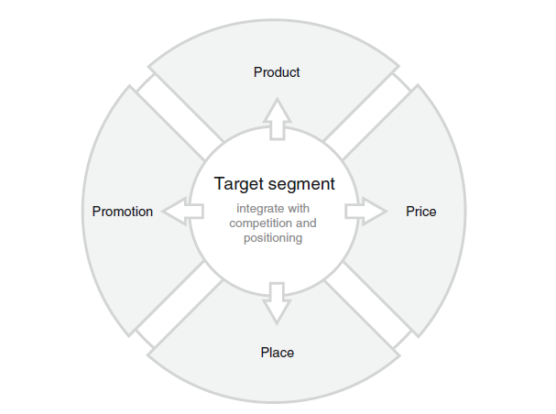

**11.2 Product**

When shaping the product dimension of the marketing mix, organizations must align their offerings with the specific needs of target segments. In the context of the Australian vacation activities data set, identified through biclustering, the opportunity arises to illustrate how product design or modification is influenced by segment selection. Consider a destination rich in cultural heritage targeting segment 3, characterized by a strong interest in visiting museums, monuments, and gardens. To cater to this segment, product measures may involve creating a new offering, such as a "MUSEUMS, MONUMENTS & MUCH, MUCH MORE" product, complemented by an activities pass. This product aids segment members in locating activities of interest, enhancing the vacation planning process. Alternatively, targeting this segment could involve proactively promoting destination gardens as attractions in their own right. Other product-related decisions, such as naming, packaging, warranties, and after-sales support services, are integral to tailoring the product dimension to meet the unique preferences of the chosen market segment.

**Chapter 12**

**Step 10: Evaluation and Monitoring**

**12.1 Ongoing Tasks in Market Segmentation**

Market segmentation analysis is not a one-time activity but an ongoing strategic decision process. According to Lilien and Rangaswamy, segmentation should be viewed as a continuous effort. As Haley suggests, the dynamic nature of the world requires marketers to continuously monitor their markets. After implementing a segmentation strategy, two essential ongoing tasks arise:

1. **Effectiveness Evaluation:** Regular assessment is crucial to determine the success of the segmentation strategy. Efforts invested in market segmentation analysis and customizing the marketing mix should result in increased profits or better alignment with organizational goals. If not, the segmentation strategy may need adjustment.
2. **Continuous Monitoring:** Recognizing the dynamic nature of the market, ongoing monitoring is essential. Consumer behaviors evolve, environmental factors change, and competitors take new actions. This monitoring process can range from regular reviews by the segmentation team to utilizing highly automated data mining systems that provide real-time insights.

**12.2 Evaluating the Success of the Segmentation Strategy**

The evaluation of market segmentation strategy effectiveness aims to ascertain whether the development of a customized marketing mix for specific segments has yielded anticipated benefits for the organization. In the short term, the primary goal for most organizations is increased profit, while non-profit organizations may focus on criteria such as donations or volunteer recruitment. Continuous monitoring of these measures allows ongoing assessment of the segmentation strategy's impact. Additionally, taking a longer-term perspective involves measuring the effectiveness of targeted positioning. A tracking study, for example, can reveal how the organization is perceived in the market. A successful segmentation strategy should result in the organization being increasingly recognized as adept at satisfying specific needs, providing a competitive advantage as the target segment views it as a preferred supplier.

**12.3 Stability of Segment Membership and Segment Hopping**

The stability of segment membership refers to the consistency of individuals or entities within a market segment over time. It is essential for marketers to assess whether the characteristics defining a segment remain relatively constant, ensuring the efficacy of targeted marketing efforts. On the other hand, segment hopping involves individuals or entities shifting between different market segments due to changing preferences or external factors. Both stability and segment hopping dynamics impact the reliability of segmentation strategies, influencing the effectiveness of marketing initiatives and the organization's ability to adapt to evolving consumer behaviors. Continuous monitoring and analysis are crucial for understanding these dynamics and making informed adjustments to maintain a successful segmentation strategy.

**Case Study : Fast Food**

**Git Hub Like of Code Conversion of R programming into Python Language is Here :**

[**https://github.com/SAPAN-PATEL/Case-Study-Fast-Food**](https://github.com/SAPAN-PATEL/Case-Study-Fast-Food)